

**Minor Project**

**Report**

Submitted in Partial Fulfillment of the

Requirement for Award of the Degree

of

**DIPLOMA**

in

COMPUTER SCIENCE ENGINEERING

By

**Rishabh Chaurasiya(11802606)**

**Mona Patel (11815585)**

**Shiv Shankar Mahato (11812651)**

Under the Guidance of

Ms.Payal Chaabra & Mrs.Sapna

**Department of Polytechnic**

**LOVELY PROFESSIONAL UNIVERSITY**

**PHAGWARA, PUNJAB (INDIA)-144411**

**2019-20**

**CERTIFICATE**

Certified that minor project work entitled “**NOW:-notes on web**” is a bonafide work carried out in the 5th semester by “**, Rishabh Chaurasiya, Mona Patel** and **Shiv Shankar Mahato**” in partial fulfillment for the award of Diploma in Computer Science and Engineering from School of Polytechnic, Lovely Professional University, Jalandhar, Punjab during the academic year 2019-2020.

(Project Guide signature)

**ACKNOWLEDGEMENT**

Foremost, we would like to express our sincere gratitude to our advisors Ms. Payal Chabra and Ms. Sapna for the continuous support in our studies and project. Their guidance helped us all the time to complete this minor project. We could not have imagined having better minor project mentors for our ”**NOW:-notes on web**” project. We would also like to thank our parents, brothers and sisters for having given us their undisputable support throughout, as always, for which our expression of thanks likewise does not suffice. Also, we thank our friends and classmates for supporting us.

Rishabh Chaurasiya (11802606)

Mona Patel (11815585)

Shiv Shankar Mahato (11812651)

(Students signature)

**INDEX**

1. Certificate………………………………………………………………………….……(2)
2. Acknowledgement……...…………………………………………………….………...(3)
3. Introduction……………………………………………………………………………..(5)
4. Objective………………………………………………………………………………..(5)
5. Specifications
   1. Software specifications……………...……………………………………….…(6)
   2. Hardware specifications……………………...…………………………...…...(10)
6. User requirements…...……………..………………………………………………...(10)
7. Features and Constraints………………...…………………………………….……....(11)
8. Flowchart……………………………………………………………………...………(12)
9. Source code………………………………………………………………..…………..(13)
10. Screenshots..………………………………………………………………..…………(20)
11. Future scope…………………………………………………………………...……....(25)

1. INTRODUCTION

In this, modern technology every work is being done digitally, then why not the studies. So, we made a website for digital and modern studies.

Many of time students unable to attend the lecture and they miss the valuable topics and many of time teachers does not give the notes.

So, we made a website for digital and modern studies.

This website is basically for PPTs .In this website you can ensures all types of your academic PPTs .The PPTs which are being uploaded in this website that are relevant with your syllabus. By using this website students can easily download the PPTs from here. Moreover in this website Previous question papers and modelpapers are available. By visiting this website you can specify the previous year question paper. Mostly Question paper or ppts are available of CSE department.

1. OBJECTIVES
2. The main objective of this project is building a website which will help users to study and download course material online.
3. It is a online approach for better and clear understanding of course study.
4. Notes On Web will get unique interface where they can avail all the details of course items, and study on time and also can gain knowledge through uploaded ppts.
5. This website will act as unique and efficient way to learn online their courses through ppt.

1. SPECIFICATIONS
   1. Software Specification
2. **Xampp :-** It is a window web development environment. It allows you to create web applications with PHP and MySql database Servers. It also comes with PHPMyAdmin to easily manage your database. Stands for "Windows, Apache, MySQL, and PHP." WAMP is a variation of [LAMP](https://techterms.com/definition/lamp) for Windows systems and is often installed as a [software](https://techterms.com/definition/software) bundle (Apache, MySQL, and PHP).

It is often used for [web development](https://techterms.com/definition/web_development) and internal testing, but may also be used to serve live websites. The most important part of the WAMP package is [Apache](https://techterms.com/definition/apache) (or "Apache HTTP Server") which is used run the [web server](https://techterms.com/definition/web_server) within Windows. By running a local Apache web server on a Windows machine, a web developer can test [webpages](https://techterms.com/definition/webpage) in a [web browser](https://techterms.com/definition/web_browser) without publishing them live on the Internet. WAMP also includes [MySQL](https://techterms.com/definition/mysql) and [PHP](https://techterms.com/definition/php), which are two of the most common technologies used for creating [dynamic websites](https://techterms.com/definition/dynamicwebsite).

MySQL is a high-speed database, while PHP is a scripting language that can be used to access data from the database. By installing these two components locally, a developer can build and test a dynamic website before publishing it to a public web server. While Apache, MySQL, and PHP are open source components that can be installed individually, they are usually installed together. One popular package is called "WampServer," which provides a user-friendly way to install and configure the "AMP" components on Windows.

1. **PHP :-** PHP is a server side scripting language. that is used to develop Static websites or Dynamic websites or Web applications. PHP stands for Hypertext Pre-processor, that earlier stood for Personal Home Pages. PHP scripts can only be interpreted on a server that has PHP installed.

The client computers accessing the PHP scripts require a web browser only. A PHP file contains PHP tags and ends with the extension ".php". PHP performs system functions, i.e. from files on a system it can create, open, read, write, and close them.

PHP can handle forms, i.e. gather data from files, save data to a file, through email you can send data, return data to the user. You add, delete, modify elements within your database through PHP.

Access cookies variables and set cookies. Using PHP, you can restrict users to access some pages of your website. PHP is a recursive acronym for "PHP: Hypertext Preprocessor". PHP is a server side scripting language that is embedded in HTML. It is used to manage dynamic content, databases, session tracking, even build entire e-commerce sites.

It is integrated with a number of popular databases, including MySQL, PostgreSQL, Oracle, Sybase, Informix, and Microsoft SQL Server. PHP is pleasingly zippy in its execution, especially when compiled as an Apache module on the Unix side. The MySQL server, once started, executes even very complex queries with huge result sets in record-setting time. PHP supports a large number of major protocols such as POP3, IMAP, and LDAP. PHP4 added support for Java and distributed object architectures (COM and CORBA), making n-tier development a possibility for the first time. PHP Syntax is C-Like. PHP is forgiving: PHP language tries to be as forgiving as possible.

1. **MySql :-** MySQL is an Oracle-backed open source relational database management system ([RDBMS](https://searchdatamanagement.techtarget.com/definition/RDBMS-relational-database-management-system)) based on Structured Query Language ([SQL](https://searchsqlserver.techtarget.com/definition/SQL)). MySQL runs on virtually all platforms, including [Linux](https://searchdatacenter.techtarget.com/definition/Linux-operating-system), [UNIX](https://searchdatacenter.techtarget.com/definition/Unix) and [Windows](https://searchwindowsserver.techtarget.com/definition/Windows). Although it can be used in a wide range of applications, MySQL is most often associated with web applications and online publishing.

MySQL is an important component of an open source enterprise stack called [LAMP](https://whatis.techtarget.com/definition/LAMP-Linux-Apache-MySQL-PHP). LAMP is a web development platform that uses Linux as the operating system, [Apache](https://whatis.techtarget.com/definition/Apache) as the web server, MySQL as the relational database management system and [PHP](https://whatis.techtarget.com/definition/PHP-Hypertext-Preprocessor) as the object-oriented scripting language. (Sometimes [Perl](https://whatis.techtarget.com/definition/Perl) or [Python](https://whatis.techtarget.com/definition/Python) is used instead of PHP).

Originally conceived by the Swedish company MySQL AB, MySQL was acquired by Sun Microsystems in 2008 and then by Oracle when it bought Sun in 2010. Developers can use MySQL under the GNU General Public License ([GPL](https://searchdatacenter.techtarget.com/definition/GNU-General-Public-License-GNU-GPL-or-simply-GPL)), but enterprises must obtain a commercial license from Oracle.

Today, MySQL is the RDBMS behind many of the top websites in the world and countless corporate and consumer-facing web-based applications, including Facebook, Twitter and YouTube.

1. **HTML :-** HTML stands for Hypertext Markup Language. It allows the user to create and structure sections, paragraphs, headings, links, and blockquotes for web pages and applications. HTML is not a programming language, meaning it doesn’t have the ability to create dynamic functionality. Instead, it makes it possible to organize and format documents, similarly to Microsoft Word.

When working with HTML, we use simple code structures (tags and attributes) to mark up a website page. For example, we can create a paragraph by placing the enclosed text within a starting ***<p>*** and closing ***</p>*** tag. Overall, HTML is a markup language that is really straightforward and easy to learn even for complete beginners in website building.

[Web browsers](https://en.wikipedia.org/wiki/Web_browser) receive HTML documents from a [web server](https://en.wikipedia.org/wiki/Web_server) or from local storage and [render](https://en.wikipedia.org/wiki/Browser_engine) the documents into multimedia web pages. HTML describes the structure of a web page [semantically](https://en.wikipedia.org/wiki/Semantic_Web) and originally included cues for the appearance of the document.

HTML lacks some of the features found in earlier hypertext systems, such as [source tracking](https://en.wikipedia.org/wiki/Source_tracking), [fat links](https://en.wikipedia.org/wiki/Fat_link) and others. Even some hypertext features that were in early versions of HTML have been ignored by most popular web browsers until recently, such as the link element and in-browser Web page editing. Sometimes [web developers](https://en.wikipedia.org/wiki/Web_developer) or browser manufacturers remedy these shortcomings.

1. **CSS :- C**ascading **S**tyle **S**heets, fondly referred to as CSS, is a simple design language intended to simplify the process of making web pages presentable.CSS handles the look and feel part of a web page.

Using CSS, you can control the color of the text, the style of fonts, the spacing between paragraphs, how columns are sized and laid out, what background images or colors are used, layout designs, variations in display for different devices and screen sizes as well as a variety of other effects.CSS is easy to learn and understand but it provides powerful control over the presentation of an HTML document. Most commonly, CSS is combined with the markup languages HTML or XHTML.  You can write CSS once and then reuse same sheet in multiple HTML pages. You can define a style for each HTML element and apply it to as many Web pages as you want.CSS has a much wider array of attributes than HTML, so you can give a far better look to your HTML page in comparison to HTML attributes.

1. **Browser :-**  web browser or Internet browser, a browser is a [software](https://www.computerhope.com/jargon/s/software.htm) program to present and explore content on the [World Wide Web](https://www.computerhope.com/jargon/w/www.htm). These pieces of content, including pictures, videos, and web pages, are connected using [hyperlinks](https://www.computerhope.com/jargon/h/hyperlink.htm) and classified with [URIs](https://www.computerhope.com/jargon/u/url.htm) (Uniform Resource Identifiers). This page is an example of a [web page](https://www.computerhope.com/jargon/w/webpage.htm) that can be viewed using a browser. Examples - Internet Explorer, Chrome.
   1. **Hardware Specifications**
2. **Operating System:** Window XP, Window 10 and others
3. **Processor:** Pentium 2.0,Intel,AMD and above
4. **Ram:** 500 MB
5. **Hard Disk Space:** 1 GB
6. USER REQUIREMENTS
7. Every user should be comfortably able to work with computer, and plug and play devices like mouse and keyboard.
8. They must have an active working internet connection.
9. They must have any web browser which is upgraded to latest version.
10. They must also have basic knowledge of English language.
11. FEATURES AND CONSTRAINTS

5.1 Features :-

1. User friendly
2. Interactive and efficient
3. Secure login-logout
4. Easy to access

5.2 Constraints

1. Graphical User Interface is only in English .
2. Email ID and password is used for identification of user.
3. Only Registered users will be authorized to use the services
4. Flowchart

The following diagram demonstrates the working and flow of the ”NOW:-notes on web”.

|  |
| --- |
| Sign In  Home  Register  Sign In  PPTs  Model Paper  Home  Website Starts |

**Codes And Screenshots**

Home



Register

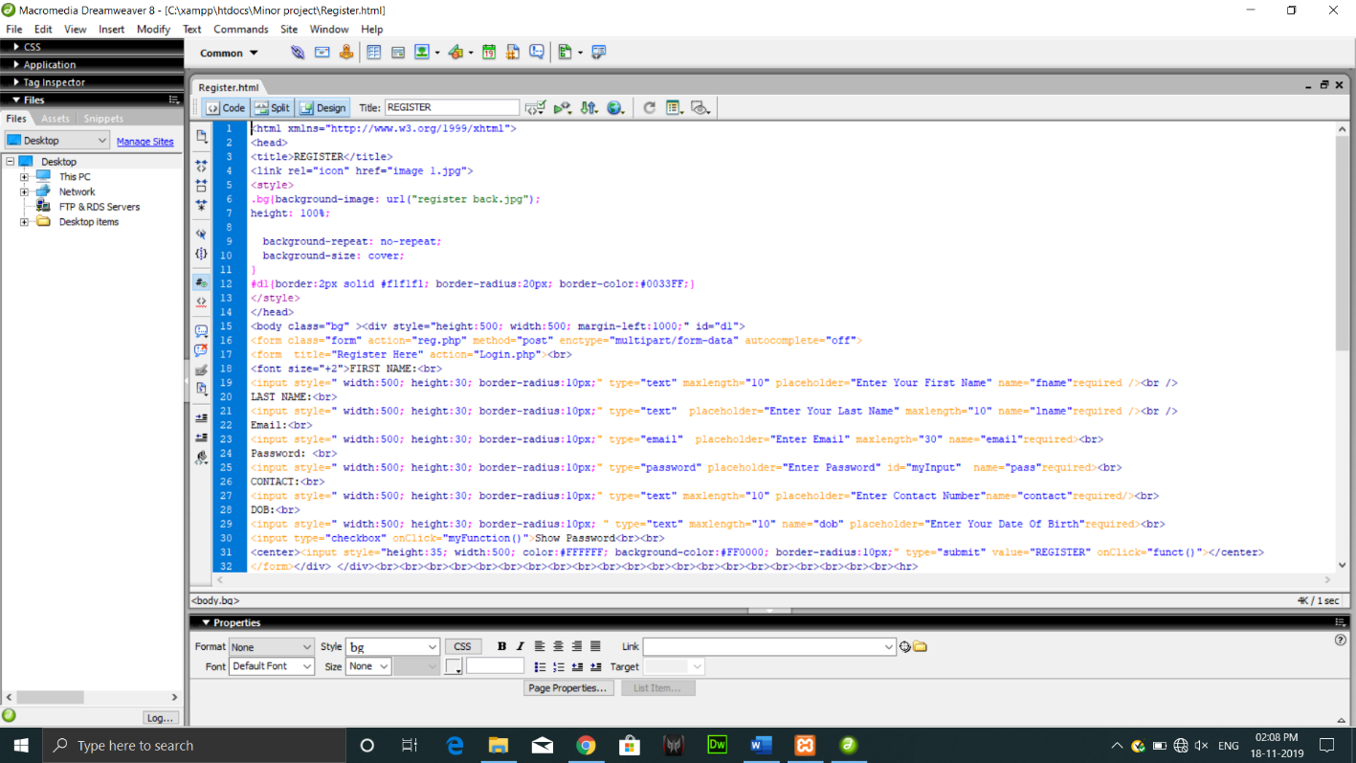

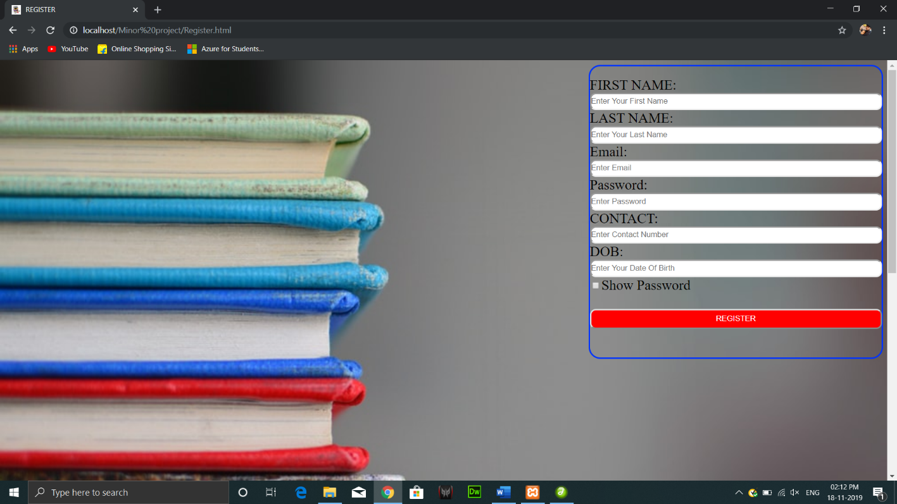

Sign In

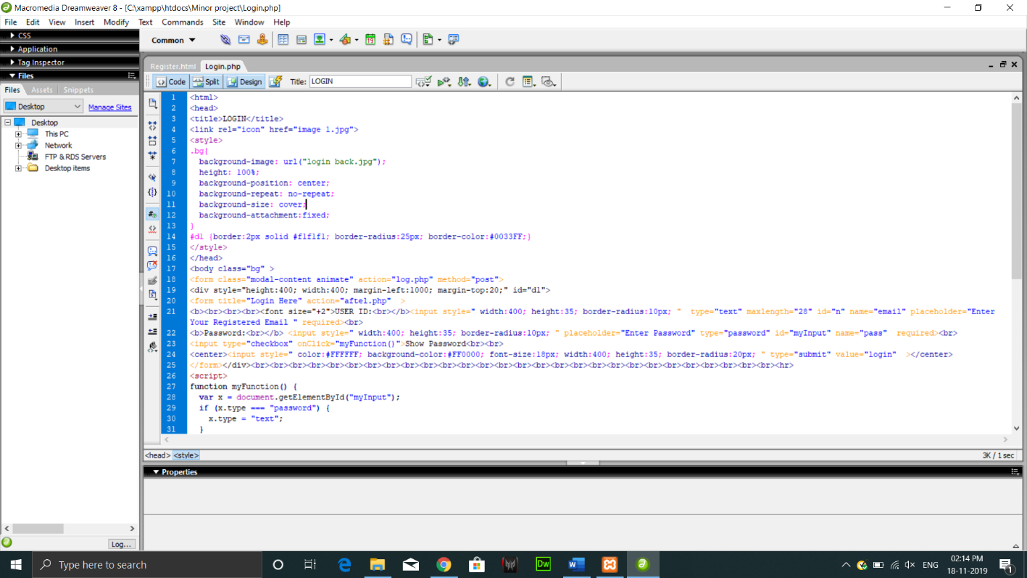

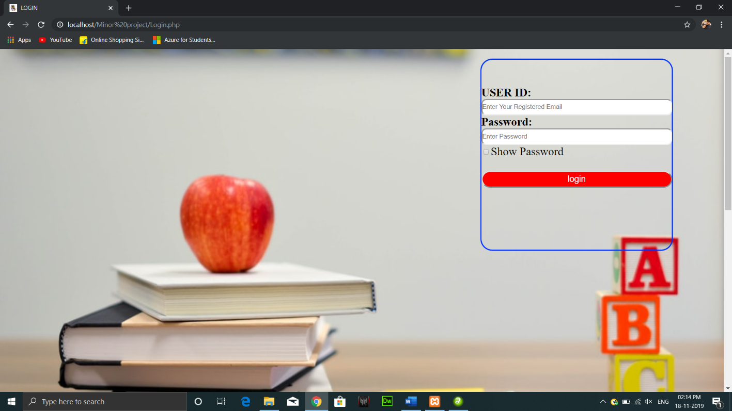

PPTs

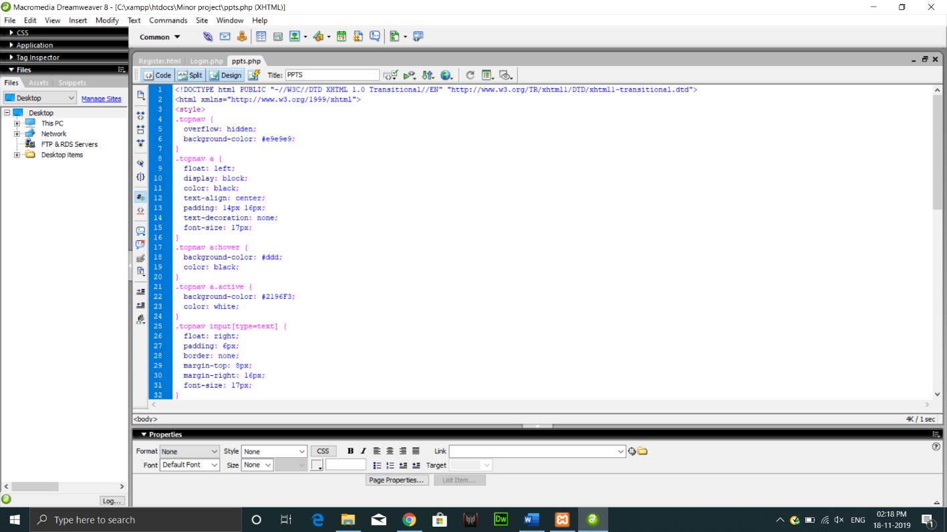

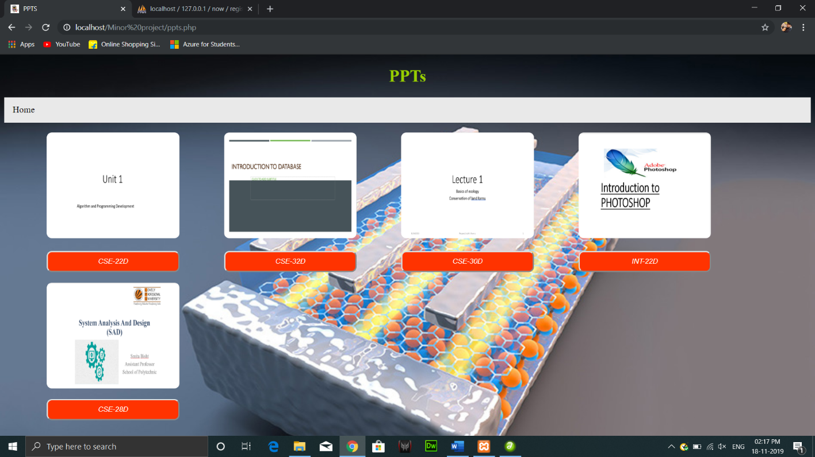

1. Future Scope:-

The project “**NOW:-notes on web**” will be very helpful for the user as it will provide

Up- to- date knowledge of the courses. Incase if there is some circumstances occur

with the students due to which he had not attended the corresponding course class then

they can get their course ppts through this.

Through this they can cover up their course in a very efficient way which may enhance

their future.